Tavs’ Topics

The new Taverners News & Review

Thurs 2 January | Training | Copleston 8pm
Sun 5 January | 1st v. Mart. Wands (a) | 2nd v. Gladwells (h)
Thurs 9 January | Training | Copleston 8pm
Sun 12 January | 1st v. Bourne Vale R (h)
Thurs 16 January | Training | Copleston 8pm
Sun 19 January | 1st v. Mart. Old Boys (h) | 2nd v. Borussia Mart. (a)

The first half of the season can best be described as ‘not without its problems’ - ranging from suffering some heavy defeats, losing the 1st team’s place in the Sunday Shield through fielding an ineligiible player, injuries and what seems to be a recurring problem of finding enough players on a week-by-week basis to field two teams.

The regular availability of players – or lack of it – is a difficulty facing most local football clubs – both Saturdays and Sundays and this is illustrated by the fact that the ISFL MB Division One has already lost 3 teams out of a starting line-up of 12.

We recently wrote to every signed-on player requesting help in securing the club’s future by (a) looking for new players and (b) making themselves available as often as possible.

Both angles are extremely important.

The first team – although bottom of the table and without a league win – have certainly seen a resurgence of enthusiasm and never-say-die spirit in recent weeks and might well have picked up more points had it not been for a couple of controversial penalty incidents!

And they do seem to have been enjoying the games recently!

The reserves have shown that – when they have a full side – they are equal to most teams in their division and they remain in contention for the League Minor Cup.

Forthcoming fixtures / dates

Taverners Football Club

Established 1967 – affiliated to Suffolk FA – members: Ipswich Sunday Football League

December 2013

Tavs’ Topics

1st team appearances |  | 2nd team appearances |  | 1st team goals
G Cunningham | 11 | D Herridge | 11 | T Brooks | 6
M Davis | 11 | T Hollinsworth | 11 | J Brittain | 2
T Brooks | 10 | W Lawrence | 10 | C Henry | 2
D Stevens | 10 | B Burgess | 9 | C Medd | 2
A Cracknell | 9 | J Holmes | 9 | D Stevens | 2
D Southgate | 9 | G Leeks | 9 | M Wray | 2
J Horsfall | 8 | M Pearson | 8 | K Bolah | 1
J Brittain | 7 | S Burrows | 7 | G Pilkington | 1
G Pilkington | 7 | G Ha | 7 | D Southgate | 1
B Burgess | 6 | G Pilkington | 7 | Z Wright | 1
R Fisk | 6 | S Cumberbatch | 6 | Own goal | 1
S High | 6 | R Sherman | 6
K Bolah | 5 | J Burrows | 5 | Total | 21
G Warden | 5 | M Davis | 5
C Henry | 4 | D Mann | 5
G Leeks | 4 | Z Wright | 5 | 2nd team goals
C Medd | 4 | K Bolah | 4 | D Herridge | 6
C Parry | 4 | M Green | 4 | G Pilkington | 4
M Wray | 4 | E Mongan | 4 | Z Wright | 4
A Beaney | 2 | D Stevens | 4 | S Creaton | 3
J Bullamore | 2 | S Creaton | 3 | K Bolah | 2
S Burrows | 2 | R Fisk | 3 | T Hollinsworth | 2
D Herridge | 2 | S High | 3 | G Leeks | 2
T Hollinsworth | 2 | P Ryan | 3 | C Parry | 2
J Burrows | 1 | A Smith | 3 | D Stevens | 2
S Cumberbatch | 1 | D Southgate | 3 | J Burrows | 1
L Gonzales | 1 | D Tennial | 3 | S Burrows | 1
G Ha | 1 | J Brittain | 2 | M Pearson | 1
C Halls | 1 | D Burrows | 2 | D Tennial | 1
J Holmes | 1 | D Vincent | 2 | Own goals | 2
W Lawrence | 1 | D Warner | 2
M Pearson | 1 | K Bowman-Boyles | 1 | Total | 33
P Ryan | 1 | J Bullamore | 1
P Strutt | 1 | A Cracknell | 1
Z Wright | 1 | C Halls | 1
 |  | C Parry | 1
 |  | A Skinner | 1
 |  | M Smith | 1
 |  | P Strutt | 1

Tavs’ Topics

Looking back…..over 47 years of Taverners FC

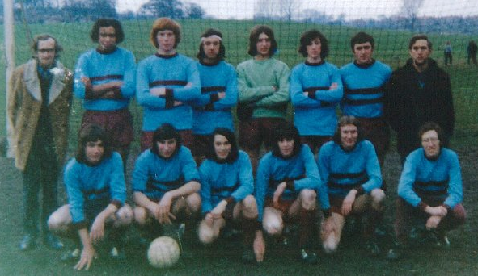

The Tavs face the camera during the 1972/73 season, our first year in the Ipswich Sunday Morning League after five seasons in the Gippeswyk Sunday League.

The photo was taken on Gippeswyk Park – our home ground then – a ground which boasted a number of football pitches in those days and a fair number of spectators.

Those pictured are:

Back row: Frank Fleming, Paul Miller, Jim Butcher, Mike Cook, Kevin Stevens, Peter Warren, David Wood & John Cook.

Front: Don Muhs, Pat Elvin, Glen Parker, John Davey, Brian Hunnisett & Bob Bullamore.

Wearing our new ‘West Ham away’ kit, the Tavs were about to play Finchley Athletic – rivals over many years – in a Division 9 game and recorded a 4-1 win. The goals came from a Glen Parker hat-trick and Pat Elvin.

In a season when Taverners won 12, drew 2 and lost 8 of their league games, Paul Miller was leading scorer with 26 goals followed by Glen on 11.

Belgium – Easter 2011

Tavs’ Topics

First team statistics - 2013/14
Clapgate Lane | A | 4-6 | League | Goals: Brooks 2 (penalties), Brittain 2
Trimley Red Devils | A | 0-5 | League
Feklixstowe Athletc 03 | A | 2-1 | Sunday shield | Goals: Brooks, Southgate
Shotley Rose reserves | H | 4-1 | Sunday shield | Goals: Stevens, Bolah, Pilkington, own goal
Trimley Red Devils | H | 1-2 | League | Goal: Brooks (pen)
Bourne Vale Rangers | A | 1-6 | League | Goal: Wright
Trimley Red Devils | A | 1-5 | Senior Cup | Goal: Wray
Ipswich Postal Legends | A | 1-8 | League | Goal: Brooks
Boxford Rovers | A | 1-2 | League | Goal: Henry
Real Orford | H | 3-3 | League | Goals: Brooks (pen), Medd 2
Martlesham Old Boys | A | 1-2 | League | Goal: Henry
Martlesham Wanderers | H | 0-5 | League
Real Orford | A | 2-2 | League | Goals: Stevens, Wray

Reserve team statistics - 2013/14
Eclipse | H | 0-6 | League
Kesgrave Kestrels | A | 3-2 | League | Goals: Herridge 3
AFC Claydon | H | 1-2 | League | Goal: Stevens
Selkirk reserves | H | 0-4 | Sunday Trophy
Brantham Athletic | A | 2-4 | League | Goals: Pilkington, Burrows
Northam Celtic reserves | A | 3-4 | League | Goals: Pilkington 2, Leeks
Felixstowe Harpers Utd res | A | 2-2 | League | Goals: Wright, Herridge
Playford reserves | H | 4-2 | League | Goals: Herridge, S Burrows, Creaton, own goal
AFC Claydon | H | 6-3 | Minor Cup | Goals: Herridge, Wright 2, Bolah, Creaton 2
Eclipse | A | 0-10 | League
Kesgrave Kestrels | H | 4-1 | League | Goals: Wright, Bolah, Parry 2
Suffolk Punch | H | 0-5 | League
Briarbank Rovers | A | 1-9 | League | Goal: Pilkington
AFC Claydon | A | 7-2 | League | Goals: Stevens, Hollinsworth 2, Pearson, Leeks, Tennial, own goal

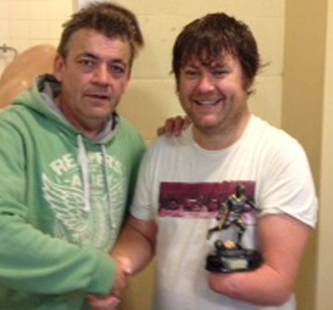
Last season saw some big Taverners appearance milestones being achieved.

Firstly, back in September, Paul Ryan played his 200th game for the Club.

Paul had been stuck on 199 for quite some time due to injury but he is pictured (top picture) with his award presented by reserve team manager Trevor Hollinsworth.

Below, Bevan Burgess celebrates his 600th appearance for Taverners with Trevor and Bob Bullamore.

Bevan joined the Tavs back in 1986 and now proudly stands second in the all-time appearance stats, behind Club Chairman Pat Elvin.

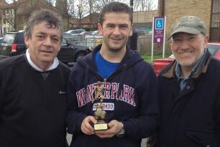



Tavs’ Topics

Tavs’ Topics

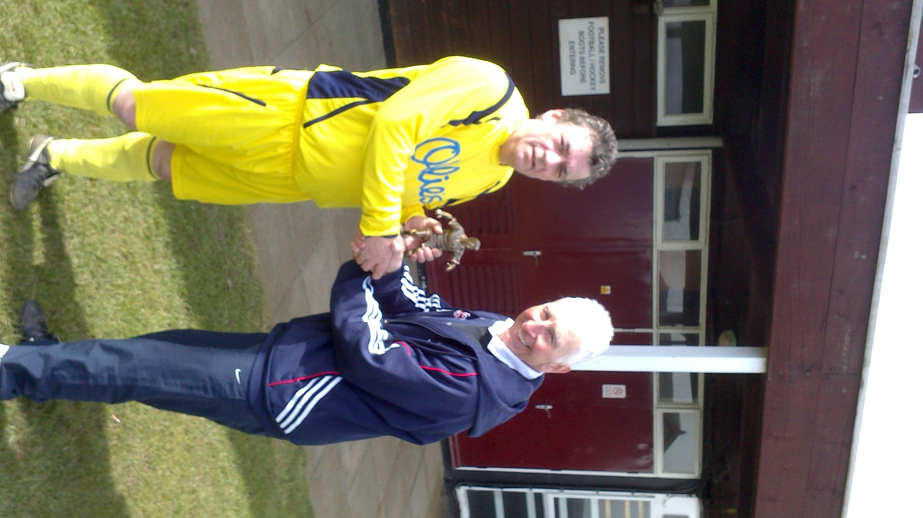
More achievements from last season …..

Top, Trevor Hollinsworth is presented with a trophy by Tavs Chairman Pat Elvin to mark his 400th appearance for the Club.

Next, Duncan Southgate also reaches the 400 match milestone and shows off the momento he has received.

Bottom, Bob Bullamore presents Matt Davis with a trophy to celebrate his 200th appearance for Taverners.

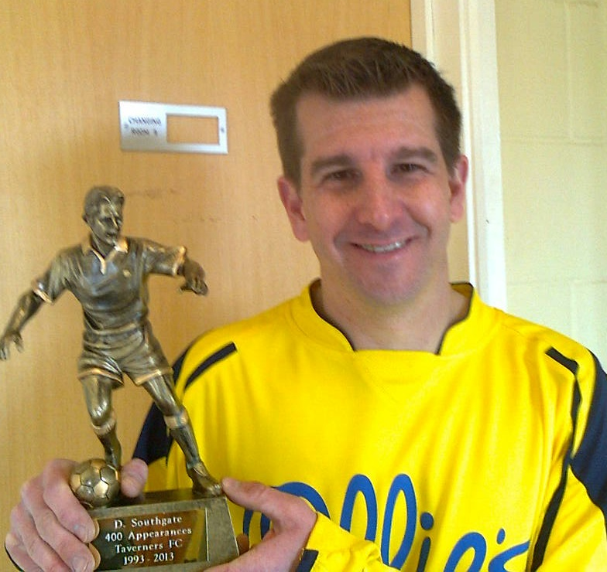

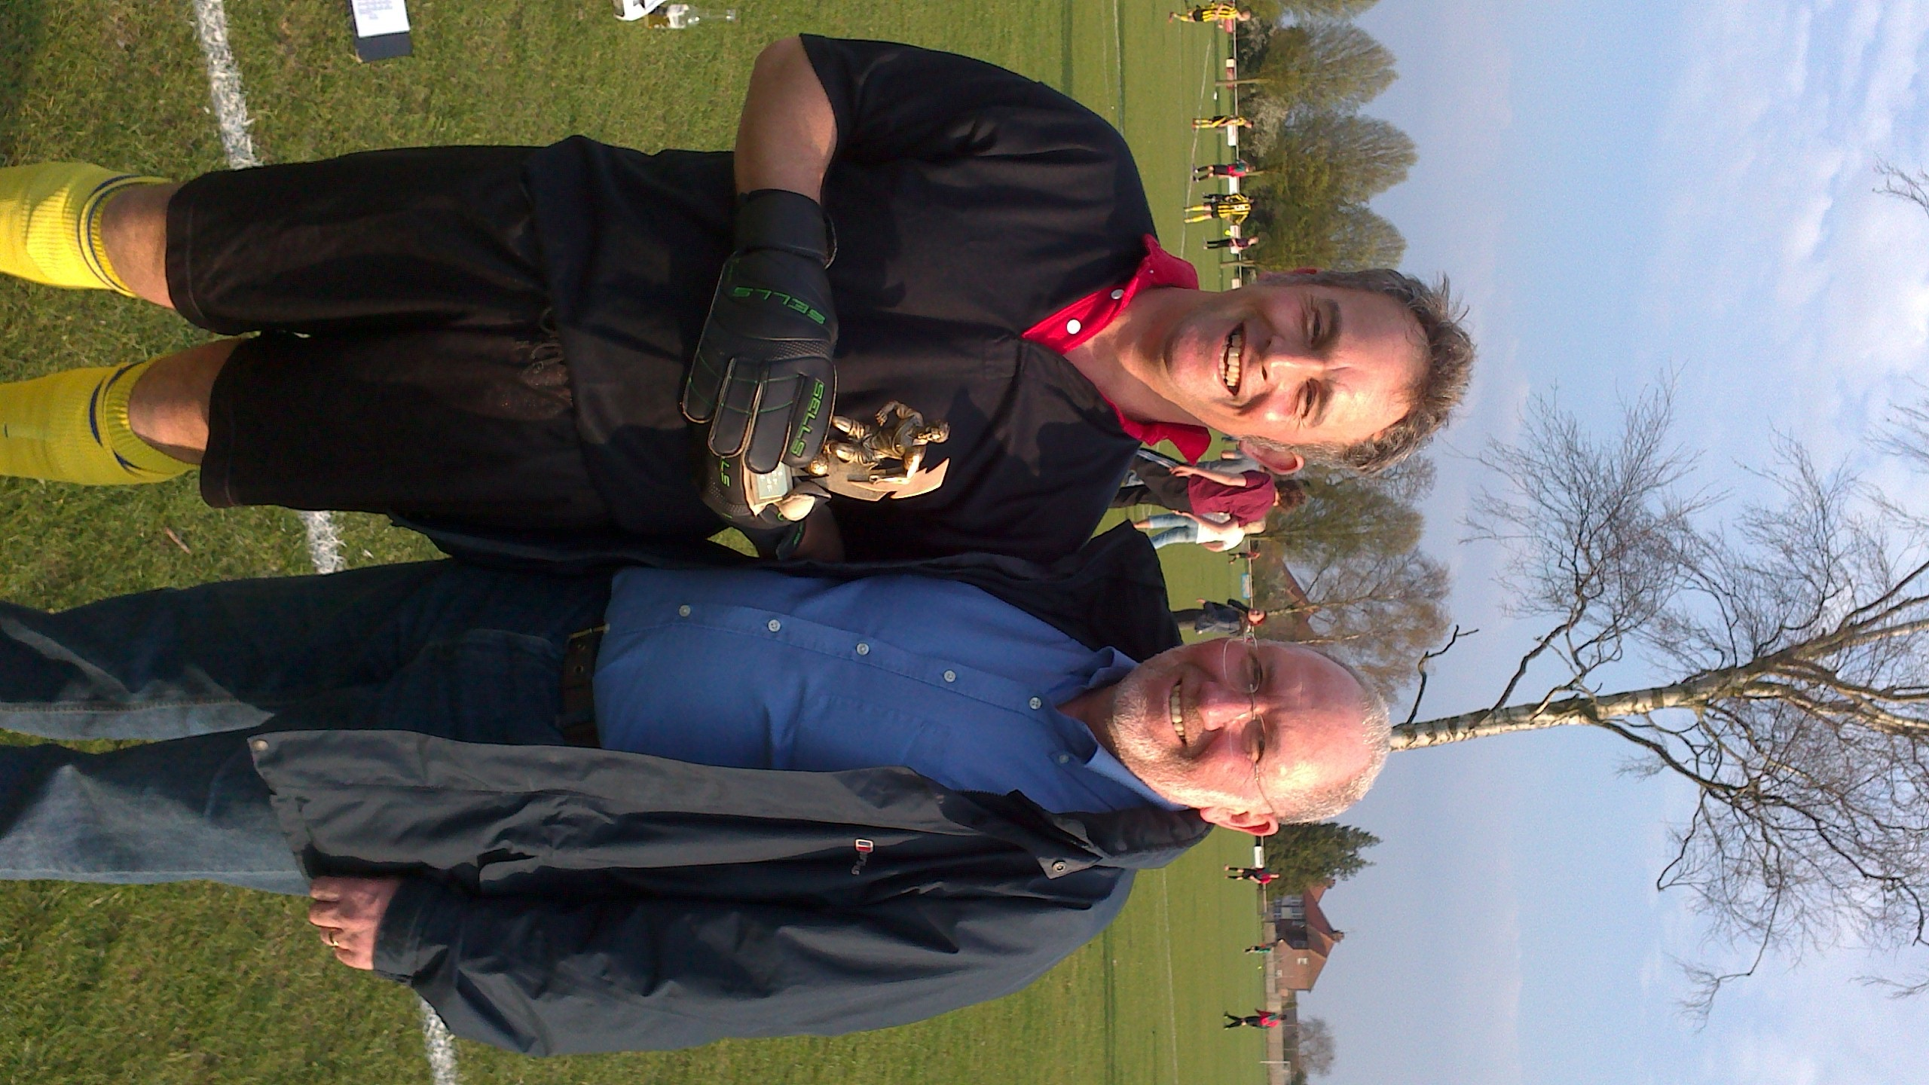

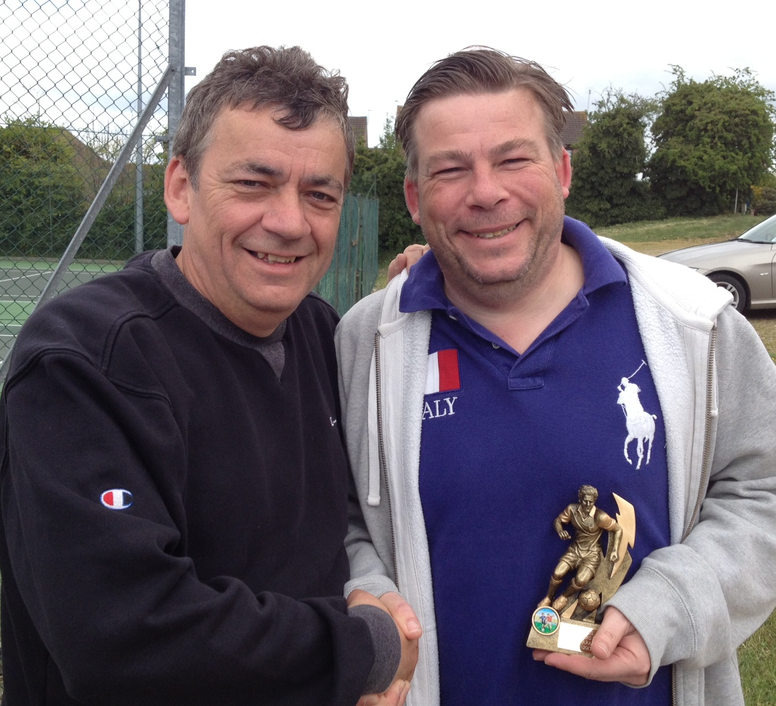
And finally…..

Trevor Hollinsworth presents Julien Holmes with a momento to mark his 200th appeance for the Tavs.

Tavs’ Topics

Club annual awards
2012/13

Award | 1st team | 2nd team
Players’ Player | Paul Bestley | Geoff Leeks
Manager’s Player | Tom Brooks | Sam Burrows
Goal of the Season | Lee Glenister | Bobby Cutting
Top goalscorer | Tom Brooks & Ben Baldwin | Gary Pilkington

Award | Winner
Clubman | Matt Davis
Most Improved | Graeme Warden
Best Newcomer | Darren Herridge
Presidents’ Cup | Trevor Hollinsworth

Tavs’ Topics

(as at the end of the 2012/13 season)
APPEARANCES |  |  | 200 + |  | APPEARANCES |  |  | 200 +
Name | 1st | 2nd | Total |  | Name | 1st | 2nd | Total
P Elvin | 523 | 201 | 724 |  | C Bloom | 228 | 54 | 282
B Burgess | 198 | 416 | 614 |  | M Cura | 157 | 119 | 276
D Stevens | 396 | 197 | 593 |  | M O'Leary | 228 | 30 | 258
G Cunningham | 369 | 218 | 587 |  | G Parker | 195 | 55 | 250
T Howard | 366 | 170 | 536 |  | N Bennett | 88 | 160 | 248
A Spivey | 401 | 70 | 471 |  | R Bullamore | 233 | 14 | 247
J Bullamore | 322 | 101 | 423 |  | T Brooks | 217 | 18 | 235
T Hollinsworth | 252 | 163 | 415 |  | M Flude | 200 | 14 | 214
T Hedges | 349 | 65 | 414 |  | M Davis | 39 | 169 | 208
D Southgate | 284 | 122 | 406 |  | P Ryan | 156 | 52 | 208
G Pilkington | 143 | 219 | 362 |  | I Green | 30 | 176 | 206
A Glover | 282 | 62 | 344 |  | M Moore | 181 | 22 | 203
T Pilbro | 225 | 99 | 324 |  | I Scott | 17 | 185 | 202
C Dawson | 211 | 89 | 300 |  | C Lushington | 154 | 46 | 200
M Parker | 151 | 139 | 291 |  | J Holmes | 7 | 193 | 200
GOALS |  |  | 50 + |  | GOALS |  |  | 50 +
Name | 1st | 2nd | Total |  | Name | 1st | 2nd | Total
T Hollinsworth | 152 | 74 | 226 |  | G Pilkington | 18 | 74 | 92
G Cunningham | 129 | 95 | 224 |  | G Parker | 70 | 20 | 90
P Elvin | 158 | 14 | 172 |  | T Pilbro | 59 | 29 | 88
P Miller | 139 | 8 | 147 |  | M Cura | 39 | 34 | 73
D Stevens | 77 | 61 | 138 |  | J Riley | 59 | 4 | 63
M Flude | 112 | 18 | 130 |  | R Sherman | 5 | 58 | 63
S Baker | 35 | 85 | 120 |  | A Spivey | 56 | 6 | 62
A Glover | 71 | 31 | 102 |  | B Ormsby | 2 | 59 | 61
E Goulding | 20 | 78 | 98 |  | J Davey | 55 | 6 | 61

Tavs’ Topics

Looking back…..over 47 years of Taverners FC

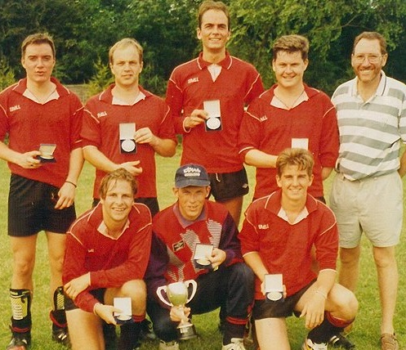

It’s the Summer of 1994 and the Tavs celebrate retaining the Barnston (Essex) 5-a-side competition trophy.

Back row: Kevin Oxborrow, Ray Sherman, Andy Spivey, Paul Ryan & Bob Bullamore

Front: Mark ‘Bubble’ Smith, Mark Moore & Duncan Southgate.

keeping in touch

This publication will be going to all current members together with our database of ex-players and supporters who we hope enjoy keeping in touch.
For complete up-to-the-minute detail – with photos and weekly updated stats and reports as well as features on ‘days gone by’ - do visit the Club’s website:
www.tavernersfc.org.uk

Tavs’ Topics

Daren reaches 600!

We have seen one big milestone this season – Daren Stevens played his 600th game for the Tavs and he is shown receiving a memento from Club Chairman Pat Elvin.

Daren is now third in Taverners FC’s all-time appearance list – behind Pat himself and Bevan Burgess.

